|  | **NATIONAL UNIVERSITY OF SCIENCE AND TECHNOLOGY POLITEHNICA BUCHAREST** |  |
| --- | --- | --- |

**Doctoral School of Automatic Control and Computer Science**

**SCIENTIFIC REPORT**

**no.** 1 **from** 2025

**PhD student: Marian BĂNICĂ**

| **Prof. Dr. Ing. Ciprian-Gabriel Lupu**  POLITEHNICA Bucharest | PhD Supervisor |
| --- | --- |

|  |
| --- |

| **Prof. Dr. Ing. Florin Pop**  POLITEHNICA Bucharest | Mentoring commission member |
| --- | --- |
| **Prof. Dr. Ing. …………………………**  University of Craiova | Mentoring commission member |
| **Dr. Ing. …………………………**  POLITEHNICA Bucharest | Mentoring commission member |

**BUCHAREST 2025**

______________

# **Smart Living Solutions** using **Robotic Workforce**

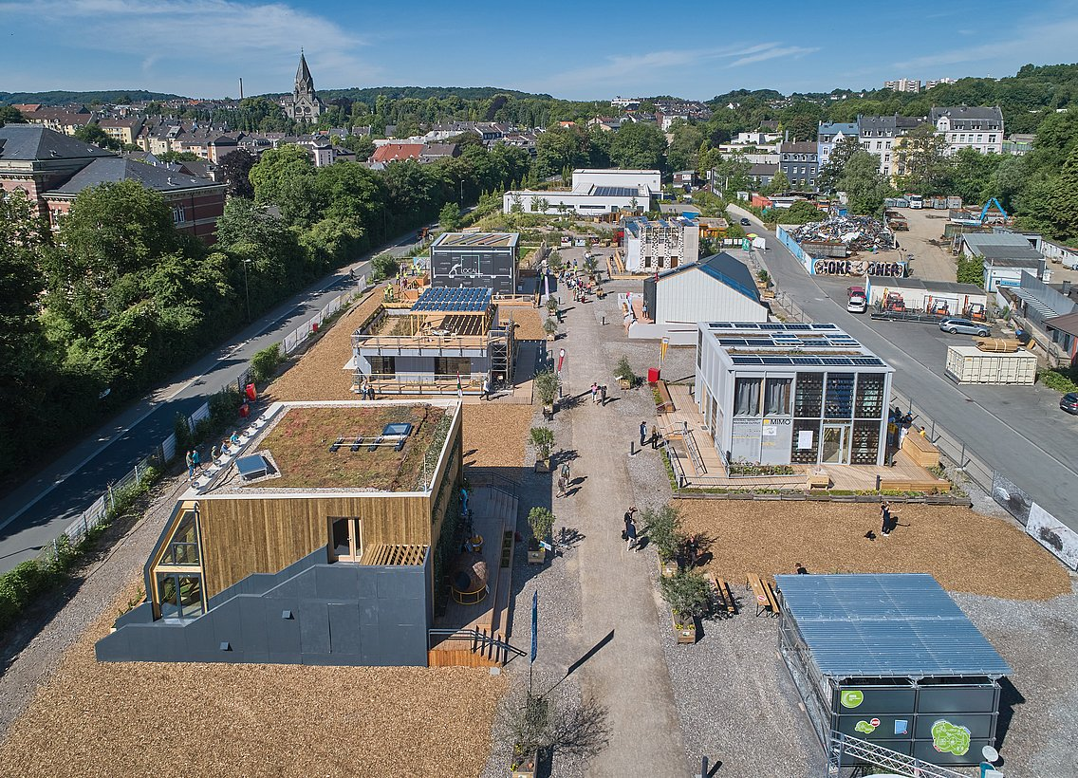

**Abstract**

This report provides a review of the current state of smart living solutions and the integration of robotic workforces within these environments. It covers the **foundational definitions, technological advancements, and diverse applications** that can be seen both in scientific literature but also at engineering trade fairs such as 2025 Hannover Messe (March 31-April 4, 2025, Hannover, Germany)

An important part of this report is dedicated to the challenges associated with integrating robotics into smart living, including issues of privacy, security, user acceptance, ethical considerations, and regulatory compliance in different countries.

Most of the actual work is based on the living solutions provided by Wuppertal Living Lab NRW (North Rhine Westphalia) Wuppertal, Germany[1], with focus on two models of smart houses:

1. **Local+ Aachen [2]**

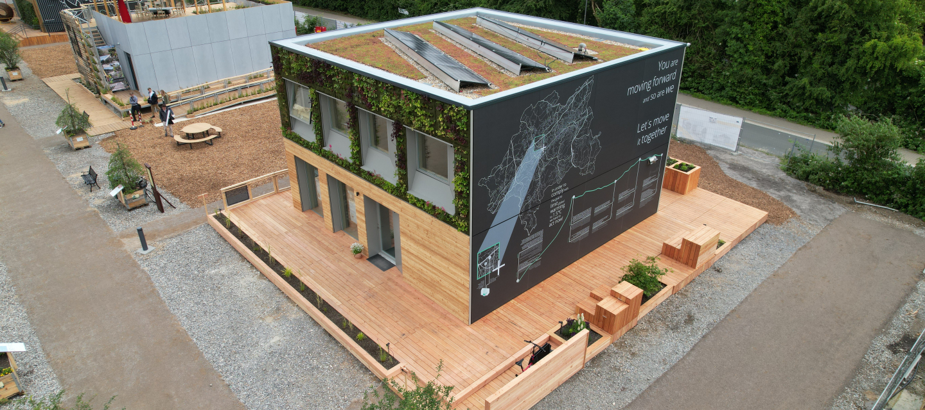

The **LOCAL+** project, developed by FH Aachen (University of Applied Sciences Aachen)[3], addresses the challenges of sustainable and socially inclusive urban housing.

The design concept focuses on creating adaptable living environments while reducing the ecological footprint of residential construction. The project combines a modular solid wood structure with integrated photovoltaic and green façade systems, enabling the building to cover approximately two-thirds of its energy demand through on-site generation. Flexibility is achieved through the use of movable “CUBEs,” multifunctional furniture modules that allow residents to reconfigure their living spaces according to changing needs.

Beyond energy efficiency and resource-conscious construction, LOCAL+ creates new forms of collective living, targeting the growing demographic of single-person households and promoting shared use of space and resources. [4]

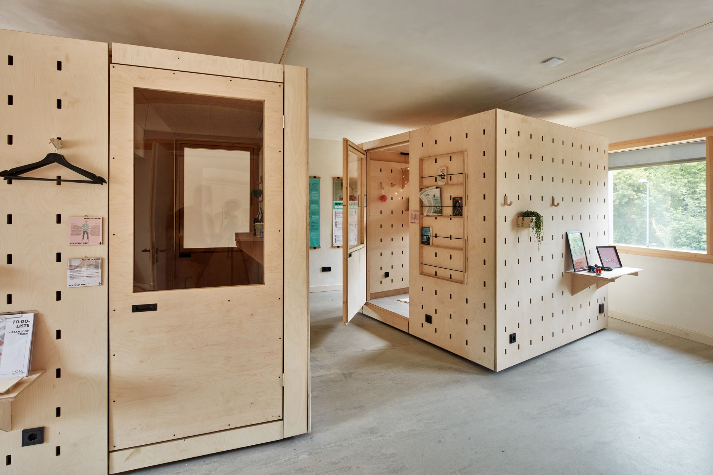

1. **MIMO - Hochschule Dusselforf** [5]

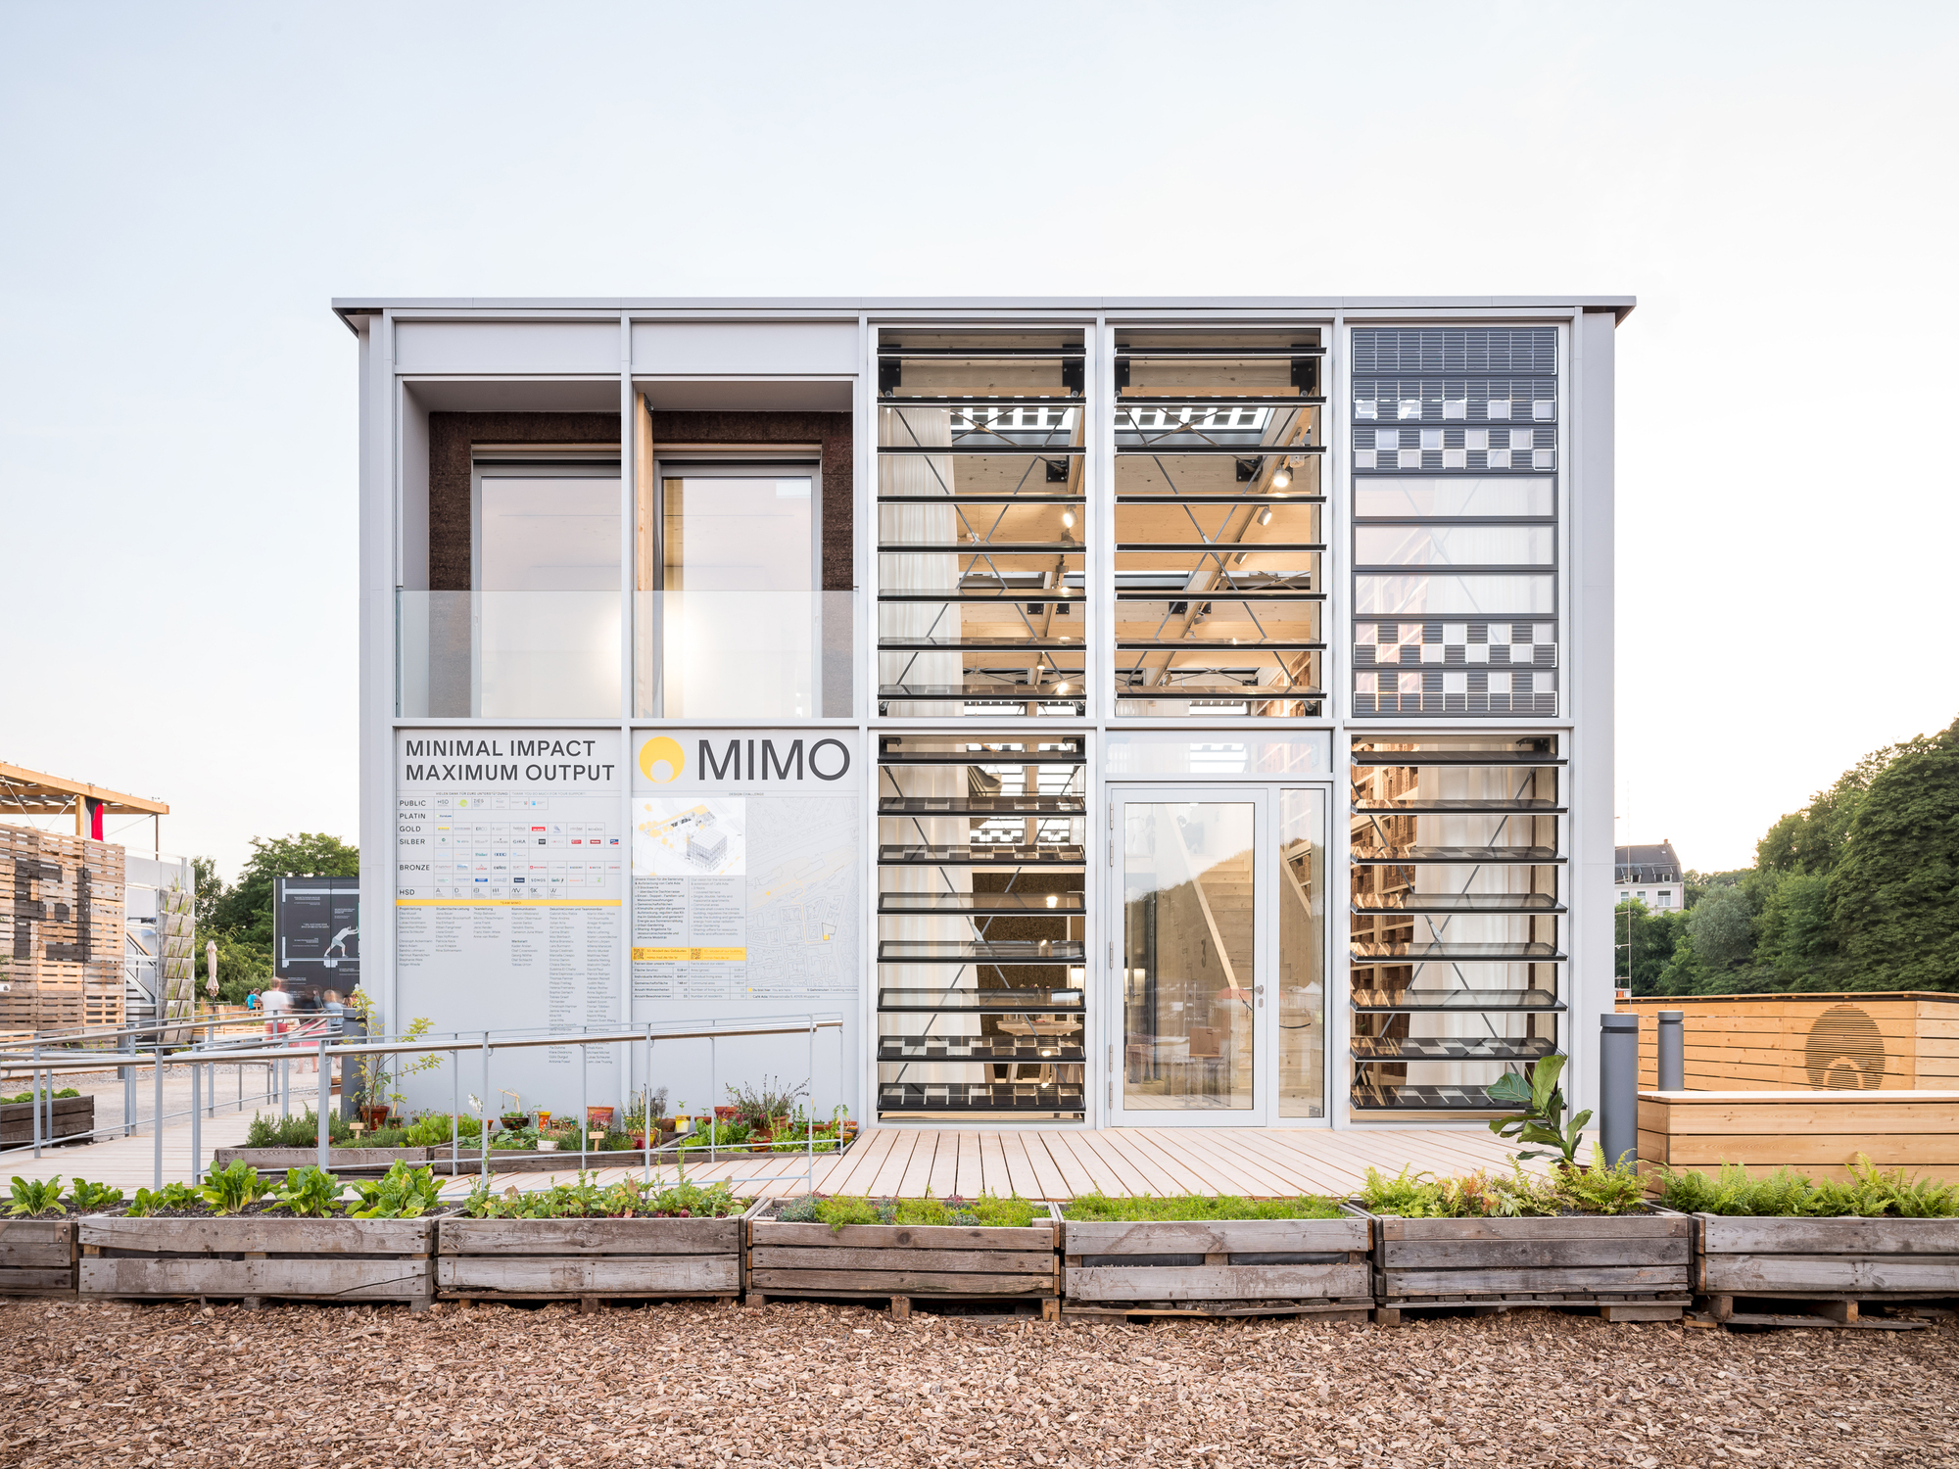

The **MIMO (Minimal Impact – Maximum Output)** project, developed by Hochschule Düsseldorf, explored strategies for sustainable urban densification and building refurbishment. Using a modular solid wood construction system, MIMO demonstrated how prefabricated units can reduce embodied energy, streamline assembly, and enable flexible residential layouts.

The report also outlines strategic methodologies for implementing a living lab focused on smart living solutions utilizing a robotic workforce.

## **1. Introduction to Smart Living and Robotic Workforce**

Smart technologies are part of everyday life, creating what we call “smart living.” At the same time, robots are getting better and easier to use, making it possible to build a “robotic workforce” that can handle many different jobs. This section explains what both terms mean and looks at how they connect, as well as the new possibilities that come from combining them.

### **1.1 The Ev**olution **of Smart Living**

Smart living is a **lifestyle** that applies technology to improve quality of life, increase efficiency, and reduce waste in everyday activities.¹ It covers areas such as homes, workplaces, and urban transport, aiming to raise living standards while supporting economic efficiency and lowering environmental impact.⁴ In academic terms, smart living is viewed as a **multi-dimensional concept** built on four main areas: **technology, security, health, and education.**¹

Key features of smart living environments include energy efficiency, the use of big data, Internet of Things (IoT) adoption, smart transport systems, effective waste management, and modern electricity grids.⁵ Another important factor is **Human Action Recognition (HAR)**, which supports the success of smart living services.²

Smart living is closely linked to the wider idea of smart cities, which are generally described through six components: **smart economy, smart people, smart governance, smart mobility, smart environment, and smart living.**²

### **1.2** Use **of the Robotic Workforce**

Robots are generally defined as machines programmed through computer algorithms to carry out both simple and complex tasks.⁷ A central feature that separates robots from standard automated machines is their ability to adapt tasks in response to changes in their environment.⁷

The robotic workforce can be grouped into several categories: industrial robots, professional and personal service robots, and collaborative robots (cobots).⁷

The applications of the robotic workforce are broad and varied. In industry, robots are used for welding, painting, assembly, and material handling.⁷ In agriculture, they support planting, harvesting, spraying, and monitoring crops.⁸ Within logistics, AMRs manage order picking, sorting, and transport, while robotic arms handle packing.⁸ Robots are also valuable in performing tasks that are repetitive, tedious, or dangerous for humans, such as inspecting pipelines or cleaning hazardous materials.⁸

The rise of collaborative robots and mobile robots is reshaping safety practices and human-robot interaction (HRI). Unlike traditional industrial robots, where safety was ensured through strict physical separation in guarded areas,⁷ cobots and mobile robots are built to work directly alongside humans.⁸ This shift makes old separation measures outdated.¹¹ As a result, new methods for risk assessment and control must be developed and tested.¹¹ Research into HRI has therefore become essential, moving beyond basic task execution to address mutual understanding, predictability, trust, and safety in shared workspaces.¹² This change emphasizes the need to study how people perceive and interact with robots in close proximity, a key challenge for their successful use in domestic and workplace environments.

### **1.3 Synergies and Opportunities**

The integration of a robotic workforce presents major opportunities for strengthening smart living solutions. Robots can improve efficiency, increase safety, and enhance overall quality of life within smart environments.¹ They can take on repetitive and physically demanding tasks, easing the workload of human caregivers and allowing for more personalized care.¹⁴ Practical applications include home automation, healthcare support, and security services.³

Beyond task automation, the growing use of robots also drives job transformation and the creation of new employment opportunities.¹³ Their integration often requires human oversight and maintenance roles, combining technical expertise with traditional job functions.¹³ In addition, new jobs continue to emerge in the design, programming, manufacturing, data collection, and analysis of robotic systems.¹³

The adoption of a robotic workforce thus offers a dual opportunity: improving smart living solutions while also fostering new human-robot relationships and generating new skill-based career paths. While public discussions on robotics often stress the risk of job loss, available evidence shows that robots not only “transform” existing jobs but also “create new opportunities.”¹³ This highlights that the relationship between smart living and robotics is not simply about automation replacing human labor, but about a co-evolution where humans and robots collaborate to develop new forms of work. These roles require specialized knowledge in fields such as robot design, programming, maintenance, and data analysis.¹³

For living lab environments, this means research should go beyond assessing technical performance. It must also examine human factors such as training, adaptation, and collaboration models that build trust and efficiency in human-robot partnerships. Taking this broader approach will help create a more connected, effective, and sustainable smart living ecosystem.

## **2. Current State-of-the-Art in Smart Living Solutions**

This section provides a detailed examination of the current technological landscape of smart living solutions, exploring their fundamental components, diverse applications across various domains, and the emerging trends shaping their future. A particular emphasis is placed on the critical role of data management and interoperability standards in realizing the full potential of these intelligent environments.

### **2.1 Core Components and Key Indicators**

Smart living environments are fundamentally built upon the integration of advanced Information and Communication Technology (ICT), smart sensing technology, robust big data analytics, and intelligent decision-making frameworks.2 These technological foundations serve to optimize energy consumption, enhance healthcare services, and generally improve living standards for inhabitants.3

**Table 2.1: Key Dimensions and Indicators of Smart Living Solutions**

| Dimension/Category | Key Indicators/Components |
| --- | --- |
| **Foundational Technologies** | Internet of Things (IoT), Big Data, Information and Communication Technology (ICT), Smart Sensing Technology, Ubiquitous Computing, Intelligent Decision-Making, Human Action Recognition (HAR) |
| **Core Operational Aspects** | Context Awareness, Data Availability, Personalization, Privacy, Real-time Processing, Interoperability, Multimodality, Resource-Constrained Processing |
| **Societal & Environmental Impact** | Quality of Life, Efficiency, Waste Minimization, Energy Savings, Reduced Carbon Footprint, Health, Education, Security, Citizen Participation |
| **Urban & Infrastructure Elements** | Smart Economy, Smart People, Smart Governance, Smart Mobility, Smart Environment, Smart Living (as a component), Transportation Systems, Waste Management, Smart Electricity, Smart Lighting, Smart Water, Smart Traffic, Smart Parking, Smart Buildings, Smart Industry |

### **2.2 Applications Across Domains**

The concept of smart living has found diverse applications across numerous domains, extending its influence beyond mere residential automation.

In **smart homes**, the application of intelligent systems has revolutionized various sectors, including healthcare ecosystems, efficient household energy consumption management, and enhanced security and emergency response protocols.18 Smart homes are designed to detect potential threats and initiate appropriate actions based on the nature and severity of these threats, thereby ensuring a safe, secure, and comfortable lifestyle for their inhabitants.18

Within **healthcare**, smart IoT-based applications have brought about transformative changes. They enable advanced assisted living solutions 3, comprehensive health monitoring systems 18, and even specialized applications such as navigation systems for visually impaired individuals.18 These technologies are increasingly utilized to support the early diagnosis of critical conditions, including cardiovascular, neurological, and pulmonary diseases.19

**Energy management** is another significant domain for smart living applications, with a primary objective to optimize energy consumption.3 This involves the efficient management of household energy usage 18 and the development of sophisticated systems that learn occupant behavior to interact dynamically with the energy grid for peak load shifting and shedding, thereby enhancing energy efficiency and reducing strain on infrastructure.20

In terms of **security and surveillance**, smart homes provide robust security and emergency response capabilities.18 Human Action Recognition (HAR) plays a pivotal role in these systems, contributing to home automation, healthcare, safety, and security by enabling real-time responses and personalized support.3 Furthermore, advanced security robotics, equipped with AI-driven analytics, are deployed for autonomous patrolling, real-time data analysis, and proactive threat detection, significantly enhancing overall security postures.21

The broader scope of smart living is intricately linked with **transportation and urban living**. It encompasses various aspects of smart cities, including smart lighting, smart water management, smart traffic control, smart parking solutions, smart buildings, and smart industry initiatives.2 AI-based smart traffic management systems, for instance, are designed to optimize traffic flow and alleviate congestion in urban environments.22

Human Action Recognition (HAR) is a foundational technology that bridges various smart living applications, enabling more intelligent and responsive systems, particularly for assisted living and human-robot interaction. HAR is not merely a supplementary component but is identified as a "critical success factor" for smart living services across a diverse array of domains, including energy management, healthcare, and transportation.2 Its core function involves the accurate identification and interpretation of human actions.3 This capability, in turn, empowers smart living systems to provide "real-time responses, delivering personalized support and assistance".3 This implies that continued investment in HAR research, especially focusing on multimodal sensing capabilities, is crucial for developing truly "smart" and adaptive environments. In such environments, robotic workforces can effectively assist, anticipate user needs, and interact naturally with residents. This advancement shifts the paradigm beyond simple automation to intelligent, context-aware assistance, directly enhancing the efficacy and user experience of robotic workforces within smart living contexts.

### **2.3 Emerging Technologies and Future Trends (2023-2025)**

The landscape of smart living solutions is continuously shaped by rapid advancements in emerging technologies, particularly Artificial Intelligence (AI).

**AI-powered personalization** is set to revolutionize User Experience (UX) and User Interface (UI) design by enabling increasingly tailored user experiences.23 AI systems analyze extensive user data to dynamically adjust UI elements, content, and navigation in real-time, leading to hyper-personalized digital interactions.24 This extends beyond simple content recommendations, evolving to adapt menu structures and even color schemes based on individual user preferences.24

The evolution of **conversational interfaces** is another prominent trend. AI chatbots and voice assistants are moving beyond basic query responses to understand complex contexts, anticipate user needs, and provide intuitive, human-like interactions.23 Future systems are expected to recognize emotional tone, predict user frustrations, and proactively offer assistance before users explicitly request it.24

**Generative AI** is also making significant inroads into UX/UI design. AI-powered design tools automate layout suggestions, optimize color palettes, and streamline UX workflows, thereby enhancing efficiency rather than replacing human creativity.24 Automated wireframing and AI-generated A/B testing variations are anticipated to become standard practices.24

A notable trend is the rise of **Zero UI design**, which aims to reduce the reliance on traditional visual interfaces. Interactions are increasingly shifting towards voice commands, gestures, and sensor-based inputs.23 Wearable devices and Augmented Reality (AR) glasses are prioritizing screen-free experiences, making technology more seamlessly integrated into the environment.23

**Immersive experiences with AR and VR** (Augmented and Virtual Reality) are redefining user engagement across various sectors, including e-commerce, education, and healthcare.23 Businesses that effectively integrate AR/VR into their platforms are poised to differentiate themselves in user experience. This includes virtual shopping experiences, interactive learning environments, and real-time AR overlays that enhance how users interact with digital content.24

Finally, **AI is transforming traditional appliances and home security systems**. AI-powered washing machines, for instance, can automatically select optimal settings 20, while smart refrigerators assist in minimizing food waste, and cooking ranges can prevent food from burning.20 Home security is significantly bolstered by AI, with advanced smart locks capable of tracking precise location and movement for enhanced access control.20

### **2.4 Data Management in Smart Living Environments**

The proliferation of Internet of Things (IoT) devices in smart homes, while offering unprecedented connectivity, also introduces significant data management challenges.

**Challenges** in this domain include the sheer volume and increasing complexity of data generated by myriad devices.26 A pervasive issue is the existence of data silos, which hinder the seamless integration and leveraging of data from heterogeneous internal and external sources.26 Ensuring the confidentiality, integrity, and availability of IoT data is a paramount concern, as smart living environments are susceptible to unauthorized access, privacy breaches, and data manipulation.27

To address these complexities, various **solutions** are being developed and implemented. Cloud-first data platforms, such as InterSystems IRIS, are specifically designed to simplify the construction and deployment of high-performance, AI-enabled applications that effectively connect disparate data and application silos.26 These platforms are engineered to support both SQL and NoSQL databases, capable of handling transactions and concurrent analytics at scale within a single database management system (DBMS) engine.26 They further enable the creation of intelligent enterprise applications powered by semantic search and generative AI across any data type.26

### **2.5 Interoperability Standards for Smart Home IoT Devices**

The successful operation of a smart home ecosystem is critically dependent on the seamless interaction between its various devices and platforms.29 Interoperability testing is therefore essential, as it validates the ability of different devices and applications to communicate and operate effectively within this integrated environment.29

Key components of interoperability testing include **protocol testing**, which ensures that various communication protocols like Wi-Fi, Bluetooth, Zigbee, and Z-Wave function together efficiently; **platform compatibility testing**, verifying seamless functionality across different operating systems such as iOS and Android; **device verification**, which ensures devices from different manufacturers can work together without compatibility issues; and comprehensive **system integration testing**, which validates the overall performance of all hardware, software, communication protocols, and applications within the smart home ecosystem.29

Several organizations are actively developing **current standards and initiatives** to address these needs:

* **ETSI (European Telecommunications Standards Institute):** The ETSI EN 303 645 standard, "Cybersecurity for Consumer Internet of Things: Baseline Requirements," updated in 2024, is widely recognized and referenced. It establishes a security baseline for connected consumer products and includes crucial data protection provisions.30
* **NIST (National Institute of Standards and Technology) - US Cyber Trust Mark:** NIST has published foundational cybersecurity guidelines for IoT device manufacturers, including the IR 8259 series and the core baseline for consumer IoT products (IR 8425).30 The U.S. Cyber Trust Mark, a voluntary labeling program launched in January 2025, is based on NIST requirements and aims to help consumers identify secure devices.30
* **ISO/IEC (International Organization for Standardization / International Electrotechnical Commission):** ISO/IEC 27402:2023 focuses on "Cybersecurity — IoT security and privacy — Device baseline requirements".30 Additionally, ISO/IEC 27403:2024 provides specific guidelines for IoT-domotics, or home automation systems.30

Despite these concerted efforts, a significant **challenge** remains: the IoT cybersecurity standardization landscape is fragmented globally.30 Different regions often adopt multiple approaches, leading to a persistent lack of unification across the industry.30

## **3. Current State-of-Art in Robotic Workforce for Smart Living**

The integration of robotic systems into daily life, particularly within smart living environments, represents a significant frontier in technological advancement. This section details the various categories and capabilities of service robots, their specific applications in domestic and assisted living settings, and the technical and economic limitations that currently impede their widespread adoption.

### **3.1 Categories and Capabilities of Service Robots**

The robotic workforce is broadly classified into industrial robots, professional and personal service robots, and collaborative robots (cobots), with an emerging category of managerial robots.7 These classifications reflect the evolving roles of robots from isolated factory automation to direct human interaction and assistance.

Various types and architectures of robots contribute to this workforce. Articulated robots, resembling human arms with multiple rotary joints, offer high flexibility for tasks requiring multi-plane movement.9 Cartesian robots, or gantry robots, operate on three linear axes, enabling precise straight-line movements, often used for pick-and-place tasks.9 SCARA robots, designed with two parallel rotary joints, excel in high-speed, precise operations within a restricted horizontal plane.9 Beyond stationary manipulators, Autonomous Mobile Robots (AMRs) and Automated Storage and Retrieval Systems (AS/RS) are crucial for dynamic operations in logistics and increasingly in domestic environments.8 Drones (UAVs) also form a part of this workforce, utilized for inspection, surveillance, and delivery.9

The functional capabilities of robots are extensive, ranging from traditional industrial applications like welding, painting, assembling, and material handling 7 to specialized tasks in agriculture such as planting, harvesting, and crop monitoring.8 In logistics, robots streamline operations by picking, sorting, and transporting orders.8 Crucially, robots are increasingly deployed for tasks deemed too repetitive, tedious, or dangerous for humans, including inspecting hazardous environments or handling toxic materials.8

A significant area of development is Human-Robot Interaction (HRI), particularly with collaborative robots (cobots) designed to work alongside human employees.8 This necessitates sophisticated sensors and feedback mechanisms that enable robots to respond dynamically to workflow changes and assist humans accurately and safely.8 HRI research extends to ensuring mutual understanding, transparency, predictability, and trust between humans and robots in shared workspaces.12

**Table 3.1: Classification and Applications of Robotic Workforce in Smart Living**

| Robot Category/Type | Key Capabilities | Application Domains in Smart Living |
| --- | --- | --- |
| **Industrial Robots** | Welding, Painting, Assembling, Moving, Testing, Palletizing | Manufacturing, Construction (e.g., modular building), Heavy-duty tasks in smart factories |
| **Professional Service Robots** | Picking, Sorting, Transporting, Inspecting, Data Monitoring/Analysis, Handling hazardous tasks | Warehousing & Logistics, Agriculture, Oil & Gas, Infrastructure Inspection, Security & Surveillance |
| **Personal Service Robots** | Home automation (cleaning, cooking, mobility assistance), Daily chores, Entertainment, Social interaction | Domestic Environments (smart homes), Assisted Living Facilities |
| **Collaborative Robots (Cobots)** | Working alongside humans, Assisting with assembly/packaging, Responding to workflow changes, Human-Robot Interaction (HRI) | Manufacturing (smart factories), Logistics, Healthcare (assisting staff), Domestic (shared tasks) |
| **Autonomous Mobile Robots (AMRs)** | Transporting goods, Sorting packages, Managing inventory, Autonomous navigation | Warehousing & Logistics, Domestic (e.g., robot vacuums, delivery robots), Healthcare (transporting supplies) |
| **Drones (UAVs)** | Inspecting structures, Monitoring environments, Surveillance, Delivery | Security & Surveillance, Infrastructure Management, Smart City monitoring, Agriculture (crop monitoring) |
| **Assistive Robots** | Medication reminders, Health monitoring, Physical rehabilitation support, Assistive feeding, Mobility support, Emotional support | Healthcare, Assisted Living Facilities, Independent Living (aging in place) |

### **3.2 Applications in Domestic and Assisted Living**

The application of robotic workforces is expanding significantly into domestic and assisted living environments, addressing a growing range of needs.

In **domestic applications**, robots are increasingly performing household tasks, evolving from simple functions like sweeping and chatting to more complex activities such as warming meals and tidying desks.34 Common examples already prevalent include robot vacuum and mop hybrids 35 and other smart robot vacuums designed to manage household messes.35

Within **healthcare and assisted living**, service robots are making substantial contributions to health monitoring, daily assistance, emotional support, and the overall efficiency of facility management in senior communities.14 These robots are capable of taking over repetitive and physically demanding caregiving tasks, thereby alleviating the burden on human caregivers and enabling more personalized care delivery.14 Specific applications include providing medication reminders, continuous health monitoring, offering physical rehabilitation support 14, and even specialized functions like assistive feeding arms for individuals with motor impairments.32 Beyond physical assistance, social robots are increasingly utilized to address mental health challenges prevalent among older adults, such as depression, anxiety, and loneliness.36

For **independent living support**, robots empower elderly individuals to live autonomously for longer periods. This is achieved through home-based care systems equipped with motion sensors, speech recognition, and health-monitoring devices.37 These systems can assist with various daily activities, enhance individual independence and autonomy, and crucially, reduce the risk of falls and other adverse events.38 Companies like Labrador Systems are at the forefront of pioneering assistive robots specifically designed to help people live more independently by physically assisting with everyday tasks, such as delivering meals, carrying laundry, or keeping critical items within easy reach.39

### **3.3 Technical Limitations and Challenges**

Despite significant advancements, the integration of robotic workforces into smart living environments faces several inherent technical limitations and challenges.

A primary hurdle is the nature of **unstructured environments**. Unlike predictable industrial settings, domestic environments are inherently open, dynamic, and unstructured.41 Homes feature personalized layouts, randomly positioned and movable objects, and the constant, unpredictable presence of people. These factors collectively increase the environmental diversity and dynamism, making robust robot operation challenging.41

Current limitations in **intelligence and autonomy** also pose significant barriers. Service robots often exhibit low intelligence for complex task execution and poor long-term autonomy (LTA) in domestic settings.41 They struggle with intricate, multi-step tasks that demand diversified discovery and reasoning, frequently requiring human intervention to complete successfully.34

## 3.4 RoboCasa: A Simulation Framework for Generalist Robots

RoboCasa[6] is a large-scale simulation framework designed to train generalist robots for everyday tasks, with a focus on home and kitchen environments. The project addresses the scarcity of massive robot datasets by using realistic physical simulation to scale environments, tasks, and data for robot learning methods.

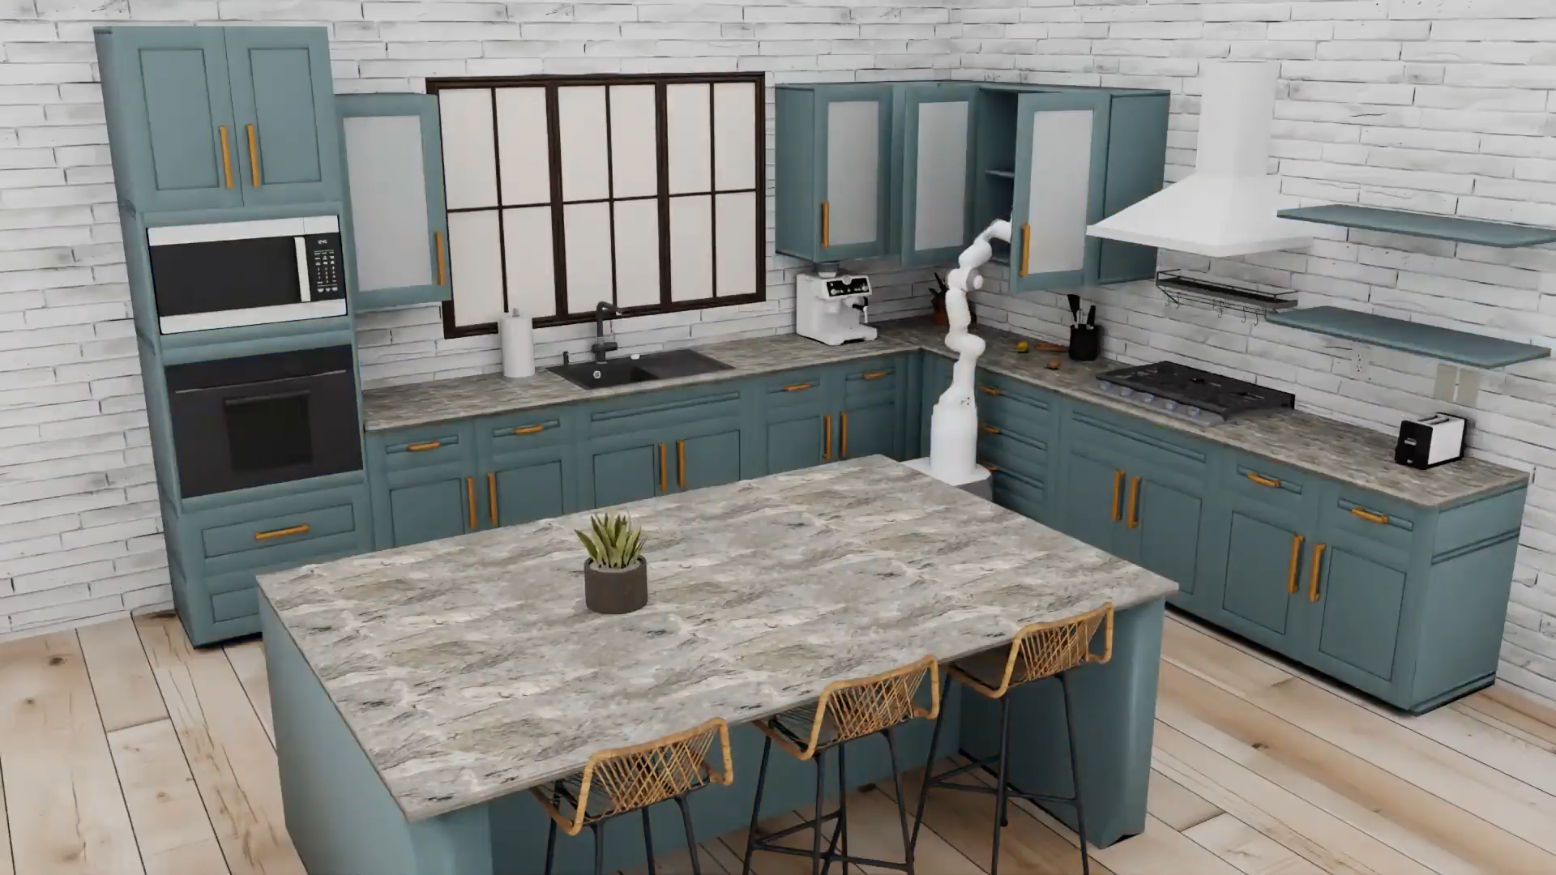

### Key Components and Contributions

* **Diverse Assets**: The framework includes over 120 kitchen scenes with various floor plans and styles, and a repository of over 2,500 3D objects across more than 150 categories. Generative AI tools, such as text-to-3D models and text-to-image models, were used to create these assets and environment textures, enhancing realism and diversity.
* **Tasks and Skills**: RoboCasa features 100 tasks for systematic evaluation, including 25 **atomic tasks** (foundational skills like picking, placing, and opening doors) and 75 **composite tasks** (sequences of skills for activities like cooking and cleaning). The composite tasks were created with the guidance of large language models (LLMs) to reflect naturalistic human behaviors and reduce human labor in task definition.
* **Massive Datasets**: The project provides a large multi-task dataset with over 100,000 trajectories. This dataset combines high-quality human demonstrations with a much larger number of synthetically generated trajectories created using the MimicGen system. Experiments show that using this generated data significantly improves a robot's generalization abilities compared to relying solely on human demonstrations, and that co-training with this data can increase success rates in real-world robot deployments.

### Significance

RoboCasa is presented as a simulation framework because it integrates a large array of tasks, room-scale scenes, and objects with AI-generated content and tasks, a combination not previously achieved by other platforms. The framework and its accompanying dataset offer a crucial resource for the robot learning community, facilitating scalable and reproducible research towards creating general-purpose home robots.

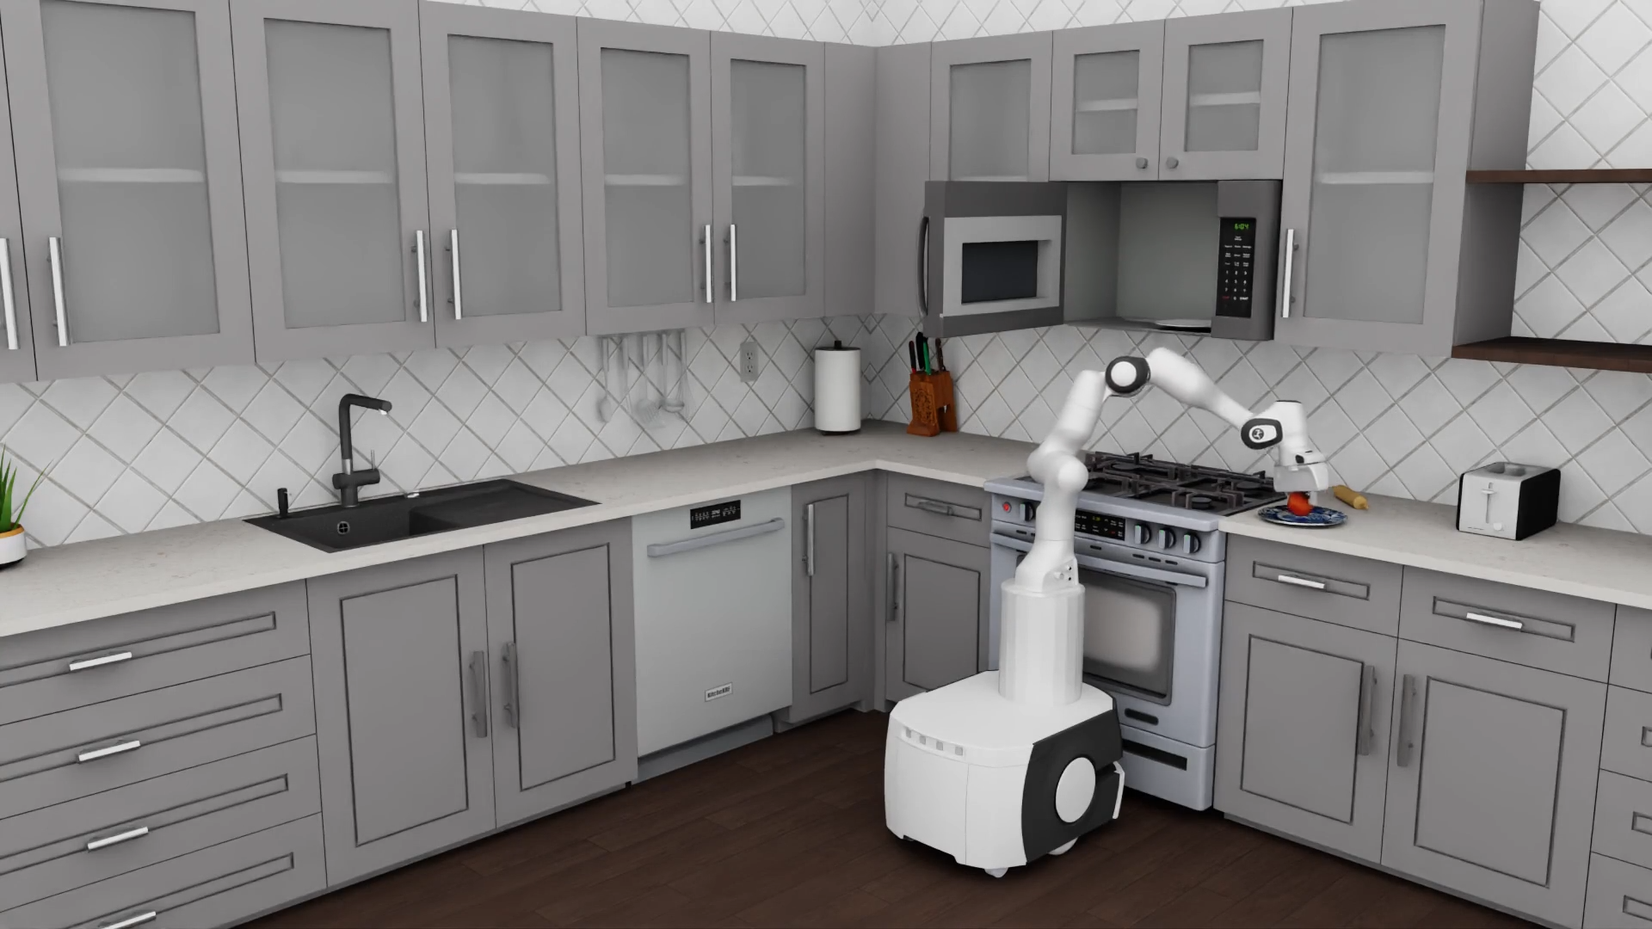

## **4. Critical Challenges and Solutions for Integrating Robotic Workforce into Smart Living Environments**

The integration of robotic workforces into smart living environments, while promising, introduces a complex array of challenges that extend beyond mere technical feasibility. This section addresses the critical issues of privacy, security, user acceptance, ethical considerations, and the evolving regulatory landscape, proposing solutions to facilitate a harmonious and effective co-existence between humans and robots.

### **4.1 Privacy and Security**

The pervasive nature of smart home devices, including integrated robots, necessitates extensive data collection, which raises significant privacy and security concerns.

**Privacy concerns** stem from the collection of vast amounts of personal data about inhabitants' habits, preferences, and daily routines.15 This leads to legitimate anxieties regarding data acquisition and processing, the potential for data leaks and misuse, and the creation of detailed user profiles.15 The constant presence of cameras, microphones, and other sensors in private spaces further intensifies questions of trust and the potential for unwanted surveillance.16

Regarding **security risks**, IoT devices are inherently vulnerable to cyber threats, including unauthorized access, identity theft, and even physical threats if their security measures are inadequate.15 Common vulnerabilities include default passwords, weaknesses in interconnected e-systems, and the exploitation of local network protocols as side-channels to access sensitive information without user awareness.16 The spectrum of attacks can range from jamming and spoofing to more sophisticated manipulation and software vulnerabilities.50

To mitigate these risks, robust **mitigation strategies** are crucial. These include implementing strong passwords, ensuring regular software updates, deploying firewalls, and establishing secure networks.15 The encryption of data transferred between devices and associated applications is essential for protecting sensitive information.15 Furthermore, consumers are advised to choose trustworthy manufacturers with a proven track record of good privacy practices and a strong commitment to security.15 Proactive measures in development involve rigorous data verification, validation, sanitization, and promptly patching known vulnerabilities.50

### **4.**2 **Ethical Considerations**

The deployment of AI-based robots in sensitive smart living contexts, particularly in caregiving roles for older adults, raises profound ethical questions that extend beyond mere technical performance.

These **moral dilemmas** are complex and multifaceted 36:

* **Autonomy vs. Automation:** A central question is whether robots, by taking over tasks, inadvertently reduce the independence of elderly individuals, or conversely, whether they empower them to live more autonomously.37
* **Consent and Privacy:** Continuous monitoring by robots, while beneficial for safety and health, raises ethical concerns about compromising personal freedom, especially for individuals with cognitive impairments who may have diminished capacity to provide ongoing consent.36
* **Emotional Support:** A critical debate revolves around whether an algorithm can genuinely replace the compassionate care or companionship provided by a human caregiver. This also includes considerations of the implications of emotional attachment that users might develop towards machines.36
* **Algorithmic Bias:** The potential for AI systems to misinterpret symptoms or make flawed decisions due to biases in their training data carries severe consequences, potentially leading to fatal outcomes.37

### **4.**3 **Regulatory Frameworks and Compliance**

The rapid evolution of robotic capabilities and their integration into smart living environments necessitate robust regulatory frameworks to ensure safety, ethics, and public trust.

The **necessity of regulation** is paramount to ensure that robots are designed and operated in a manner that prioritizes human safety and adheres to established ethical standards.52

The **evolving regulatory landscape in the European Union** provides a comprehensive example of how jurisdictions are adapting to these technological advancements:

* **AI Act:** This regulatory framework introduces divergent compliance obligations based on risk levels. High-risk applications, such as drones, will require rigorous conformity assessments, human oversight protocols, and granular data governance. Limited-risk applications, like inventory management systems, may only need to provide transparency to users about their decision-making processes. The highest-risk applications, such as workplace emotion recognition systems, are already prohibited in the EU.58
* **Other Legislative Changes:** The General Product Safety Regulation, effective in the EU since December 2024, expands safety obligations for consumer-facing products, including AI systems and robots, imposing ongoing safety, cybersecurity, and traceability responsibilities across supply chains. The UK Product Security and Telecommunications Infrastructure Act and the EU Cyber Resilience Act also impose independent cybersecurity obligations on connected devices. Furthermore, the Ecodesign for Sustainable Products Regulation establishes a framework for design obligations on machinery, mandating considerations for repairability and environmental impact.58

These regulatory developments highlight the **challenges** of ensuring compliance across diverse applications, achieving harmonization across different jurisdictions, and keeping pace with rapid technological advancements.42

Effective **solutions** involve a continuous assessment of regulatory requirements, the development of comprehensive compliance frameworks, and the integration of compliance measures directly into the design and development processes of robotic systems.52 This mandates rigorous testing and validation procedures to verify that robotic systems operate safely, ethically, and within legal boundaries, followed by ongoing monitoring and auditing throughout their lifecycle.52

## 5**. Conclusion**

The landscape of smart living solutions is rapidly evolving, driven by the integration of advanced technologies aimed at enhancing quality of life, efficiency, and sustainability. This comprehensive review highlights that smart living is a multi-dimensional concept, encompassing technological, health, security, and environmental aspects, thereby necessitating a holistic, interdisciplinary approach to its research and implementation. Concurrently, the emergence of a robotic workforce presents significant potential to augment smart living environments, moving beyond traditional industrial automation to collaborative and assistive roles that directly interact with and support human inhabitants.

Living Labs, exemplified by models such as the Wuppertal Living Lab, offer an indispensable methodological framework for addressing these multifaceted complexities. Their user-centered, real-world experimentation approach, coupled with multi-stakeholder co-creation, provides a critical bridge between laboratory control and practical application. By fostering iterative design, continuous user feedback, and robust evaluation in authentic environments, Living Labs can ensure that robotic solutions are not only functional but also socially acceptable, ethically sound, and truly enhance human well-being.

The successful implementation of a novel living lab focused on smart living solutions using a robotic workforce hinges on a strategic integration of robust technological infrastructure, advanced AI for human-robot interaction, and continuous user-centric design. This must be underpinned by a proactive engagement with ethical, privacy, and regulatory challenges from the outset. By embracing a holistic strategy that balances technical innovation with economic viability, strong ethical governance, and broad stakeholder engagement, such a Living Lab can effectively drive the development of truly smart, sustainable, and human-centric living environments for the future.

#### Works cited

1. pmc.ncbi.nlm.nih.gov<https://pmc.ncbi.nlm.nih.gov/articles/PMC10346639/#:~:text=Smart%20living%20is%20an%20innovative,%2C%20and%20education%20%5B1%5D.>
2. Human Action Recognition in Smart Living Services and Applications: Context Awareness, Data Availability, Personalization, and Privacy - MDPI<https://www.mdpi.com/1424-8220/23/13/6040>
3. Review on Human Action Recognition in Smart Living: Sensing Technology, Multimodality, Real-Time Processing, Interoperability, and Resource-Constrained Processing - MDPI<https://www.mdpi.com/1424-8220/23/11/5281>
4. Smart Living - European Commission<https://ec.europa.eu/docsroom/documents/13407/attachments/2/translations/en/renditions/native>
5. www.researchgate.net<https://www.researchgate.net/figure/Key-Indicators-for-Smart-Living_tbl1_334414360#:~:text=The%20detected%20indicators%20were%20as,%2C%20governmental%20efficiency%2C%20smart%20electricity%2C>
6. (PDF) Review on Human Action Recognition in Smart Living: Multimodality, Real-time Processing, Interoperability, Resource-Constrained Processing, and Sensing Technology - ResearchGate<https://www.researchgate.net/publication/370547104_Review_on_Human_Action_Recognition_in_Smart_Living_Multimodality_Real-time_Processing_Interoperability_Resource-Constrained_Processing_and_Sensing_Technology>
7. Working Safely with Robot Workers: Recommendations for the New Workplace - PMC<https://pmc.ncbi.nlm.nih.gov/articles/PMC4779796/>
8. Robots in the Workplace | Michigan Tech Global Campus News<https://blogs.mtu.edu/globalcampus/2023/02/robots-in-the-workplace/>
9. The Real-World Application of Robotics | UTI - Universal Technical Institute<https://www.uti.edu/blog/robotics-and-automation/application-of-robotics>
10. The Rise and Risks of Autonomous Robots in the Workplace | The Hartford<https://www.thehartford.com/insights/technology/autonomous-robots-in-the-workplace>
11. The Role of Robotics in the Future of Work - CDC Blogs<https://blogs.cdc.gov/niosh-science-blog/2022/06/03/robotics-fow/>
12. Designing Intent: A Multimodal Framework for Human-Robot Cooperation in Industrial Workspaces - arXiv<https://arxiv.org/html/2506.15293v1>
13. Robots: Helpers or Substitutes for Workers? - Federal Reserve Bank of St. Louis<https://www.stlouisfed.org/open-vault/2024/sep/are-robots-helpers-or-substitutes-for-workers>
14. Key Performance Indicators for Service Robotics in Senior Community-Based Settings<https://pmc.ncbi.nlm.nih.gov/articles/PMC11989145/>
15. Smart Home Privacy Concerns | News - Robin Data GmbH<https://www.robin-data.io/en/data-protection-and-data-security-academy/news/smart-home-applications-data-protection>
16. New research reveals alarming privacy and security threats in Smart Homes<https://engineering.nyu.edu/news/new-research-reveals-alarming-privacy-and-security-threats-smart-homes>
17. User Acceptance of a Home Robotic Assistant for Individuals With Physical Disabilities: Explorative Qualitative Study - PubMed Central<https://pmc.ncbi.nlm.nih.gov/articles/PMC11758889/>
18. Full article: Systematic analysis of smart homes: Current trends and future recommendations<https://www.tandfonline.com/doi/full/10.1080/23311916.2024.2344452>
19. Plymouth Community Homes Digital Living Lab - University of ...<https://www.plymouth.ac.uk/research/centre-for-health-technology/plymouth-community-homes-digital-living-lab>
20. The Future of Smart Homes: Trends to Watch in 2025! - GSAVS<https://gsavs.com/blog/the-future-of-smart-homes-trends-to-watch-in-2025>
21. How Robotics is Changing the Future of Security Technology<https://kabam.ai/blogs/how-robotics-is-changing-the-future-of-security-technology/>
22. [2502.02821] AIoT-based smart traffic management system - arXiv<https://arxiv.org/abs/2502.02821>
23. UX/UI Trends for 2025: Innovations That Will Transform Digital ...<https://www.nivelics.com/en/blog/ux-ui-trends-2025>
24. UX Design Trends 2025 & UI Innovations: The Future of UX ...<https://www.fullstack.com/labs/resources/blog/top-5-ux-ui-design-trends-in-2025-the-future-of-user-experiences>
25. Latest AI Breakthroughs and News: May-June 2025 - Crescendo.ai<https://www.crescendo.ai/news/latest-ai-news-and-updates>
26. Data Management System (DBMS): InterSystems IRIS Data Platform ...<https://www.intersystems.com/products/intersystems-iris/>
27. Unveiling the core of IoT: comprehensive review on data security challenges and mitigation strategies - Frontiers<https://www.frontiersin.org/journals/computer-science/articles/10.3389/fcomp.2024.1420680/full>
28. Analysis of IoT Security Challenges and Its Solutions Using Artificial Intelligence - PMC<https://pmc.ncbi.nlm.nih.gov/articles/PMC10136937/>
29. IoT Testing for Smart Home Devices: Ensuring Interoperability and Security - Compunnel<https://www.compunnel.com/blogs/iot-testing-for-smart-home-devices-ensuring-interoperability-and-security/>
30. Untitled - Connectivity Standards Alliance<https://csa-iot.org/wp-content/uploads/2025/06/Consumer-IoT-Device-Cybersecurity-Standards-Policies-and-Certification-Schemes-2025-_FINAL.pdf>
31. [2506.08890] Human-Robot Teaming Field Deployments: A Comparison Between Verbal and Non-verbal Communication - arXiv<https://arxiv.org/abs/2506.08890>
32. Real-World Trials: UW's Assistive Feeding Robot Tested Beyond the - Bioengineer.org<https://bioengineer.org/real-world-trials-uws-assistive-feeding-robot-tested-beyond-the-laboratory/>
33. Assistive Robotics Lab - YouTube<https://www.youtube.com/watch?v=ULzGK46Z4Ms>
34. Task cognition and planning for service robots - OAE Publishing Inc.<https://www.oaepublish.com/articles/ir.2025.08>
35. TP-Link: Your Smart Home, Simplified<https://www.tp-link.com/us/>
36. Ethical considerations in the use of social robots for supporting mental health and wellbeing in older adults in long-term care - Frontiers<https://www.frontiersin.org/journals/robotics-and-ai/articles/10.3389/frobt.2025.1560214/full>
37. Challenges in 2025 for AI Robots in Elderly Care | Zemplee<https://www.zemplee.com/2025/05/05/ai-robots-elderly-care-2025-challenges-ethical-questions/>
38. Revolutionizing Long-Term Care with Robotics - Number Analytics<https://www.numberanalytics.com/blog/revolutionizing-long-term-care-with-robotics>
39. Labrador Systems - A New Generation of Assistive Robots<https://labradorsystems.com/>
40. Can AI help address future home care worker shortages? | Aging and Health Technology Watch<https://www.ageinplacetech.com/blog/technology-and-ai-will-help-address-future-issues-home-care>
41. Environment Modeling for Service Robots From a Task Execution Perspective - arXiv<https://arxiv.org/html/2501.05931v1>
42. Challenges and Opportunities in the Service Robotics Industry and Future Trends<https://www.reportsnreports.com/semiconductor-and-electronics/challenges-and-opportunities-in-the-service-robotics-industry-and-future-trends/>
43. R²D²: Adapting Dexterous Robots with NVIDIA Research Workflows and Models<https://developer.nvidia.com/blog/r2d2-adapting-dexterous-robots-with-nvidia-research-workflows-and-models/>
44. Robot machine price: How much do they cost? - Standard Bots<https://standardbots.com/blog/robot-machine-price-how-much-do-they-cost>
45. Professional Humanoid Robots - RobotShop<https://www.robotshop.com/collections/professional-humanoid-robots>
46. 5 Challenges to Address in Scaling Robotics Solutions in the Workforce - ARTiBA<https://www.artiba.org/blog/5-challenges-to-address-in-scaling-robotics-solutions-in-the-workforce>
47. Robotics Maintenance and Troubleshooting: A Comprehensive Guide | Tooling U-SME<https://learn.toolingu.com/blog-start/2024/september/robotics-maintenance-troubleshooting-guide/>
48. Green Robotics: Energy Consumption & Sustainability Stats - PatentPC<https://patentpc.com/blog/green-robotics-energy-consumption-sustainability-stats>
49. Sustainable Manufacturing Series: How to Effectively Manage Robot Energy Consumption<https://www.automate.org/industry-insights/how-to-effectively-manage-robot-energy-consumption>
50. Security Considerations in AI-Robotics: A Survey of Current Methods, Challenges, and Opportunities - arXiv<https://arxiv.org/html/2310.08565v3>
51. Artificial Intelligence and the Future of Teaching and Learning (PDF) - Department of Education<https://www.ed.gov/sites/ed/files/documents/ai-report/ai-report.pdf>
52. Robot Law Compliance - Meegle<https://www.meegle.com/en_us/topics/robotics/robot-law-compliance>
53. Challenges in Seniors Adopting Assistive Robots: A Systematic Review - ResearchGate<https://www.researchgate.net/publication/309747949_Challenges_in_Seniors_Adopting_Assistive_Robots_A_Systematic_Review>
54. Enablers and barriers to the implementation of socially assistive humanoid robots in health and social care: a systematic review - PubMed Central<https://pmc.ncbi.nlm.nih.gov/articles/PMC6955545/>
55. pmc.ncbi.nlm.nih.gov<https://pmc.ncbi.nlm.nih.gov/articles/PMC11758889/#:~:text=Participants%20were%20generally%20positive%20about,could%20perform%20most%20tasks%20autonomously.>
56. Domestic Robots: Human Integration Guide - Number Analytics<https://www.numberanalytics.com/blog/domestic-robots-human-integration-guide>
57. Effects of Robot Capability on User Acceptance<https://www.ri.cmu.edu/pub_files/2013/3/LateBreakReport.pdf>
58. Robotics at a global regulatory crossroads: compliance challenges for autonomous systems<https://www.osborneclarke.com/insights/robotics-global-regulatory-crossroads-compliance-challenges-autonomous-systems>
59. Living lab - Wikipedia

<https://en.wikipedia.org/wiki/Living_lab>

1. D3.3 – Implementation Living Lab methodology - CORDIS <https://cordis.europa.eu/docs/projects/cnect/5/632905/080/deliverables/001-D33ImplementationLivingLabMethodology.pdf>
2. Living Lab Methodology - North Wales Collaborative<https://www.northwalescollaborative.wales/wp-content/uploads/2020/10/Living-lab-methodology-handbook_r.pdf>
3. Living Labs - ENoLL<https://enoll.org/living-labs/>
4. living labs, innovation, models - ENI CBC Med<https://www.enicbcmed.eu/sites/default/files/2024-05/D_WP5_OP5.7_A5.7.1_Living%20Lab%20handbook.pdf>
5. Our Facility - Robot House<https://robothouse.herts.ac.uk/facility/>
6. Smart City Living Lab | Herman Hollerith Zentrum<https://www.hhz.de/en/location/smart-city-living-lab>
7. How to Implement a Living Lab: A Guide for Cities - Factual Consulting [How to Implement a Living Lab: A Guide for Cities - Factual Consulting](https://factual-consulting.com/how-to-implement-a-living-lab-a-guide-for-cities)
8. The Living Lab approach and citizen engagement <https://living-in.eu/sites/default/files/files/the-living-lab-approach-and-citizen-engagement-1.pdf>
9. A framework for the evaluation of living labs as boundary spanners in innovation | SWEET Lantern <https://sweet-lantern.ch/wp-content/uploads/2024/02/Van-Geenhuizen-M.-2018.-A-framework-for-the-evaluation-of-living-labs-as-boundary-spanners-in-innovation.pdf>
10. A harmonized assessment method and KPIs for evaluating Living Labs - ResearchGate <https://www.researchgate.net/publication/382181444_A_harmonized_assessment_method_and_KPIs_for_evaluating_Living_Labs>
11. Living Lab NRW<https://livinglabnrw.uni-wuppertal.de/de/>
12. Veröffentlichungen <https://livinglabnrw.uni-wuppertal.de/de/veroeffentlichungen/>
13. Technology for Living - Technology for Independent Living <https://www.technologyforliving.org/technology-for-independent-living-program-til/>
14. Research - ARMLab Stanford <https://arm.stanford.edu/research/>
15. ARMLab Stanford: Home <https://arm.stanford.edu/>
16. FZI Living Lab Service Robotics - FZI Forschungszentrum Informatik <https://www.fzi.de/en/experience/house-of-living-labs/fzi-living-lab-service-robotics/>
17. Innovative, usable solutions | Intelligent Technologies for Wellness <https://uwaterloo.ca/intelligent-technologies-wellness-independent-living/>
18. Living Labs | Medical devices and health technologies - PATH<https://www.path.org/who-we-are/programs/mdht/living-labs-initiative/>
19. A roadmap for safe, regulation-compliant Living Labs for AI and digital health development<https://pmc.ncbi.nlm.nih.gov/articles/PMC12077496/>
20. Living lab business models and services – Scanbalt <https://scanbalt.org/wp-content/uploads/2020/04/Laurea-Julkaisut-137.pdf>
21. Funding | The Lemelson Foundation<https://www.lemelson.org/funding/>
22. Cascade Funding Opportunities – May 2025 <https://cascadefunding.eu/cascade-funding-opportunities-may-2025/>
23. Open Calls - Cascade Funding Hub <https://cascadefunding.eu/open-calls/>
24. Assistive Technology - Northwest Access Fund <https://www.nwaccessfund.org/general-assistive-technology-resources/>
25. Assistive Technology | ACL Administration for Community Living <https://acl.gov/programs/assistive-technology/assistive-technology>
26. The living lab approach in the smart living innovation process - Verhaal Zo-Dichtbij [The living lab approach in the smart living innovation process](https://verhaal.zo-dichtbij.nl/wp-content/uploads/2018/09/Final_Thesis_Resit_SuzanneBeijderwellen_485440sb.pdf)

# Three-Year Research Plan: Smart Living Tiny House Lab

### Executive Summary

The primary goal of this three-year research project is to design, build, and test a fully functional "tiny house mobile" that serves as a living lab for smart living solutions using a robotic workforce. The project will move from foundational infrastructure to advanced robotic integration and, finally, to user-centric testing and research dissemination, with the final deliverable being a mobile, fully operational, and research-validated smart home.

### Year 1: Foundation & Infrastructure

**Objective:** To establish the core physical and digital infrastructure of the tiny house lab.

**Phase 1: Conceptualization & Design**

**Milestone 1: Architectural Design.** Finalize the tiny house blueprint, specifying the layout, dimensions, and materials. Integrate spaces for robotic charging stations, sensors, and other smart technologies.

* **Milestone 2: Technology Stack Definition.** Select the core home automation platform (e.g., open-source frameworks, commercial hubs), choose specific IoT sensors and devices, and define the data management and control software architecture.
* **Milestone 3: Robotic Platform Selection.** Identify and procure the initial robotic platforms for integration, starting with a simple domestic service robot (e.g., cleaning, surveillance).
* **Deliverables:**
  + Detailed architectural drawings of the tiny house.
  + A comprehensive technology stack document.
  + Procurement list for all hardware and software.

**Phase 2: Initial Build & System Integration**

* **Milestone 1: Tiny House Construction.** Complete the physical build of the tiny house, including interior fittings and all necessary electrical and plumbing systems.
* **Milestone 2: Core System Installation.** Install and configure all smart home IoT devices, sensors, and the central hub.
* **Milestone 3: First Robotic Integration.** Integrate the initial service robot, focusing on basic functionalities like autonomous navigation within the tiny house and performing pre-defined tasks.
* **Deliverables:**
  + A physically complete and functional tiny house.
  + A demonstration of a connected home automation system.
  + A proof-of-concept showing a robot performing a task within the tiny house environment.

### Year 2: Integration & Advanced Capabilities

**Objective:** To expand the living lab's capabilities by integrating more complex robotic systems and developing core human-robot interaction (HRI) protocols.

**Phase 1: Advanced Robotic Integration**

**Milestone 1: Multi-Robot System.** Introduce a second robotic platform, such as an assistive or collaborative robot (cobot), to perform more complex, multi-step tasks in conjunction with the first robot.

* **Milestone 2: Data & AI Layer.** Develop and integrate an advanced data analysis and human action recognition (HAR) system. This will enable the robots to understand context and anticipate user needs.
* **Milestone 3: Seamless HRI.** Implement intuitive control interfaces (e.g., voice, gesture, app) for users to interact with the robotic workforce.
* **Deliverables:**
  + A demonstration of two or more robots working together to complete a task.
  + Functional code for HAR and contextual awareness.
  + A user interface for commanding the robotic systems.

**Phase 2: User-Centric Testing & Refinement**

**Milestone 1: Living Lab Launch.** Recruit a small cohort of participants to engage with the tiny house lab over a set period.

* **Milestone 2: Data Collection.** Use the tiny house as a research environment to collect both quantitative (system performance, energy usage) and qualitative (user feedback, observed interactions) data on all implemented technologies.
* **Milestone 3: Initial Findings Report.** Produce a preliminary report on the user acceptance, trust, and ethical challenges observed during the testing phase, based on the Challenges identified in the source report.
* **Deliverables:**
  + Raw data sets from the living lab tests.
  + A research paper draft on the initial HRI and user acceptance findings.
  + Initial system refinement plans based on user feedback.

### Year 3: Optimization & Dissemination

**Objective:** To refine the living lab based on research findings, document all work, and disseminate the results to the academic and public communities.

**Phase 1: System Optimization**

**Milestone 1: Technical Enhancements.** Implement a new iteration of the control software and robotic programming based on the user feedback and data analysis from Year 2. Focus on improving performance, reliability, and security.

* **Milestone 2: Final Integration & Polishing.** Ensure all systems, from the mobile power supply to the individual robotic units, are fully optimized and integrated for a final demonstration.
* **Milestone 3: Final Data Analysis.** Conduct a deep analysis of all collected data from the living lab, focusing on long-term trends and correlations between user behavior and system performance.
* **Deliverables:**
  + A fully optimized and integrated tiny house lab.
  + A comprehensive data analysis report.

**Phase 2: Documentation & Dissemination**

**Milestone 1: Thesis Completion.** Write the final PhD thesis, incorporating all research findings, methodologies, and conclusions from the three-year project.

* **Milestone 2: Academic Publications.** Submit multiple papers to peer-reviewed journals and conferences.
* **Milestone 3: Public Demonstration.** Create a polished public demonstration of the tiny house lab, including a video tour and a website, to communicate the project's impact beyond academia.
* **Deliverables:**
  + Completed PhD thesis.
  + Accepted research papers.
  + A public-facing report and media assets.

1. <https://livinglabnrw.uni-wuppertal.de/de/>
2. <https://www.fh-aachen.de/fachbereiche/architektur/vortraege-projekte/local>
3. <https://www.fh-aachen.de/>
4. <https://building-competition.org/EU2021/FHA> FH Aachen Project Manual7_2022_07_20.pdf
5. <https://mimo-hsd.de/>
6. <https://www.robocasa.ai>